**HydroMT Sprint session**

* **FIAT-Objects:** [**https://github.com/Deltares/FIAT-objects**](https://github.com/Deltares/FIAT-objects)
* **User manual:** SFWMD-FIAT User Manual_v1.1_040822.pdf

Fiat hazard input:

C:\Users\fuentesm\CISNE\FIAT-objects\tests\data\hazard\..

EPSG: 4326

EPSG: 32617

Small plus 2, 4, and 6 meters

Water depth. 20 meters? 20 Feet

**The model builder should harmonize projection and units in hazard maps**

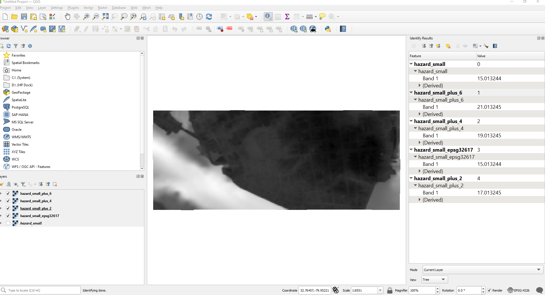

**HydroMT resources:**

* **HydroMT Fiat:** [**https://github.com/Deltares/hydromt_fiat**](https://github.com/Deltares/hydromt_fiat)
* **HydroMT Sfincs:** [**https://github.com/Deltares/hydromt_sfincs/tree/v1/main**](https://github.com/Deltares/hydromt_sfincs/tree/v1/main)
* **Hydro MT Wflow:** [**https://github.com/Deltares/hydromt_wflow**](https://github.com/Deltares/hydromt_wflow)
* **HydroMT core:** [**https://deltares.github.io/hydromt/latest/index.html**](https://deltares.github.io/hydromt/latest/index.html)

[**https://github.com/Deltares/hydromt**](https://github.com/Deltares/hydromt)

**Environments:**

* **Hydromt-fiat-dev**
* **Hydromt**
* **Hydromt-wflow**

**Explore:**

* **1 hour hydroMT core (10:40-11:52)**

Notes: It is set up by configuring the model building process from a single ini configuration file and model- and data-agnostic through a common model and data interface.

It provides commands to build, update and clip models.

Used in combination with a model plugin

Data inputs:

* + Gridded datasets such as DEMs or gridded spatially distributed rainfall datasets (represented by RasterDataset objects);
  + Tables for e.g. reclassification to convert land classes use into roughness values (represented by DataFrame objects);
  + Vector datasets such as administrative units or river center lines (represented by GeoDataFrame objects);
  + Time series with associated geolocations such as observations of discharge (represented by GeoDataset objects).

Models: These plugins have the same interface, but with model-specific file readers and writers and workflows.

Methods and workflow: Methods provide the low-level functionality such as GIS rasterization, reprojection or zonal statistics.

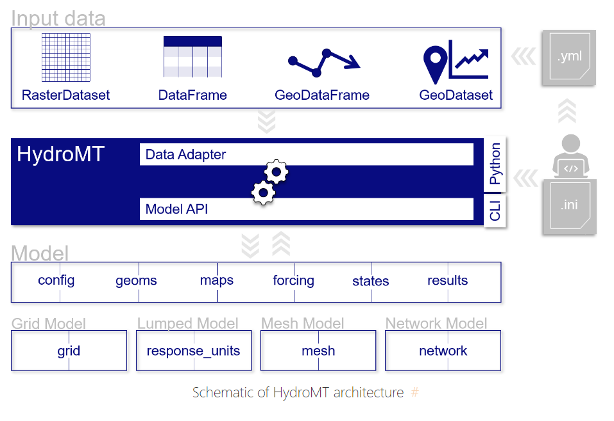

There is a .yml file (or multiple) with data inputs and a .ini file with configuration settings (for models through the API, methods and workflows). Example for wflow: C:\Users\fuentesm\CISNE\HydroMT-wflow\hydromt_wflow\examples\wflow_test_base

Toml format: <https://toml.io/en/v1.0.0#filename-extension>

<https://docs.fileformat.com/programming/toml/>

<https://github.com/Deltares/hydromt/issues/252>